Examination 1

Question 1
minimum capital requirement < solvency capital requirement
- <minimum capital requirement; prevented from taking new business
- Solvency II provides for capital charges for investment risk, underwriting risk,operational risk
  - investment risk投资过程中面临的风险
    - share price risk;interest rate risk;currency risk;default risk
  - underwriting risk卖保险过程中面临的风险
    - claim settlement higher than expected
    - mortality rate changes
    - catastrophic risk
  - operational risk内部流程/人员/系统导致的风险

lowering any of these risks will lower the related capital charges assessed for determining the capital requirement levels
- European Insurers are regulated by a European Union regulator.

Question 2
historical change: Δ(day1-day2) ——Δ(day500-day501)
- percentage change:stock price
- actual change: interest rate

Question 4
- netting: 净额结算 (portfolio’s multiple trades)
  - 风险管理角度：risk management （风险敞口risk exposure decrease）
  - 交易结算角度：settlement (只结算差额)
  - 法律/会计视角：close-out netting（把帐close-out)

Question 5
Hazard Rate违约强度(default intensity):尚未违约的情况下，下一瞬间发生违约的概率
- Function
  - constant hazard rate; hazard function; cumulative hazard; proportional hazards model
- Curve
  - Early Failure Phase; Useful Life Phase; Wear-out Phase

Question 6
- Hedgers want to get rid of risk. Speculators are willing to buy that risk in hopes of making a profit.
- They are both in otc and exchange market
- The complex derivatives increased the availability of mortgages and led to an increase in the demand for housing
- Forward and Future have linear payoff functions but options have non-linear payoff functions

Question 8
preliminary research初步调研

Question 10
why (n-1):
- u_{i}:sample expected value (smaller than population value:closer to data)
- so need to make the denominator smaller

Question 11
B.buying stock index but sell others means long/short trade or pairs trade
C.when the portfolio isn’t tradable,the price of index might diverge
D.Index Arbitrage:purchasing/selling a stock index future contract and taking the opposite position in the portfolio of stocks underlying the index

Question 12

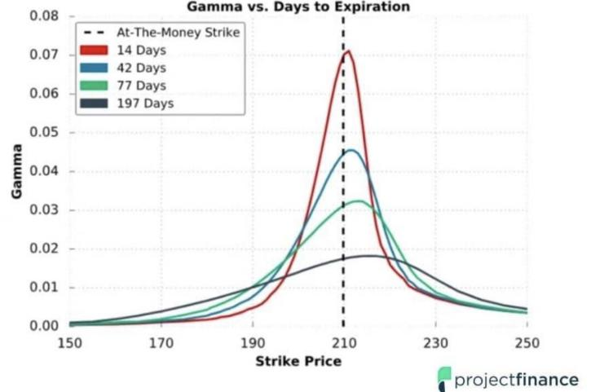

Question 14
- Long commodity position=buy forward+buy zero-coupon bond
- Long Position of Commodity = Payoff from Forward(S_{t}-F₀) +Payoff from zero coupon bond (F₀)

Question 15
VaR of the underlying asset;VaR of the option

Question 16

the use of power law:
- scale in-variance:a feature of objects or laws that do not change if scales of length,energy,or other variables,are multiplied by a common factor,and thus represent a university
- Fat Tail:
  - the probability of extreme loss will decrease slower as x increases

Question 24

the story of risk taking:
- Orange County:
  - Robert Citron bought inverse floater and use borrowed money to magnify the return
  - Problem:
    - Interest Rate increases,the bond’s price decrease
    - Leverage Increases the Loss
    - Don’t know the structure of the Derivative
  - Result
    - loss:1.6million
    - orange county goes bankruptacy
- London Whale (JP Morgan):
  - bet under the CDS and use VaR model to manage risks ( underestimate, position too high; hedge failed)
  - Point: Intrinsic Model Risk; Concentration Risk;Risk Concentration Limit
- Northern Rock:
  - British Bank:
    - Business Model: Wholesale Funding(短期借钱） + Long-term Loan
      - Market Panic; Short-term Chain broken; cannot push the finance;bank run
    - Point:
      - Liquidity Risk+ Maturity Mismatch
- LTCM:
  - Strategy: Use Price Arbitrage
  - Assumption: Market Relationship Stability
  - Problem: Russia Default; Market Panic
  - Results:
    - Mega Loss+Fed Help
  - Point:
    - During Risk,the diversification will lose effect, model risk+leverage

Question 36

\sigma_{\text{daily}} = \frac{18\%}{\sqrt{250}} \approx 1.138\%

Examination 2

Examination 3

Examination 4

